Configuring Live Tracking for users using Free version

1. From Main Menu go to Live Tracking  
   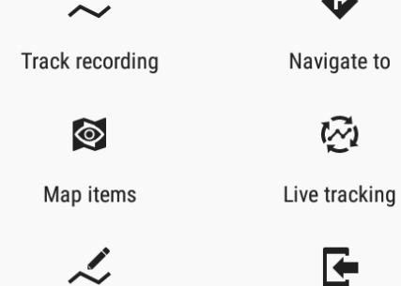
2. Select Next and Locus live tracking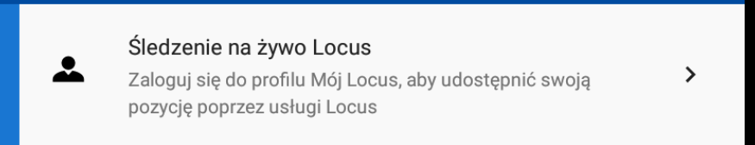
3. Login with your desired method

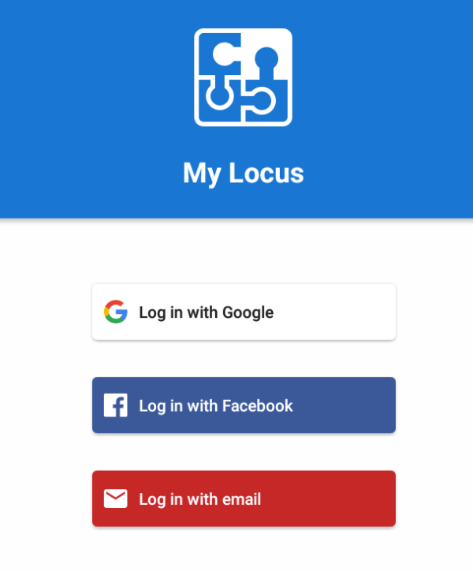

1. Extend Share with a Group option and pick Join group with access key  
     
   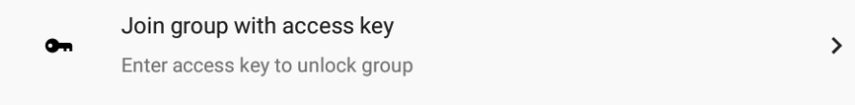
2. Enter given key in XXXX-YYYY format and click Join Group
3. Enter your nickname and click ikon on the left  
   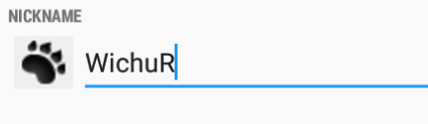
4. Select some graphical symbol to represent you on the map  
   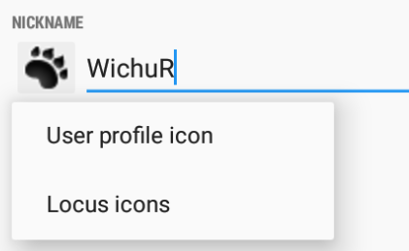
5. Click Next to get back to main map
6. Use screen configuration to add Live Tracking as below  
   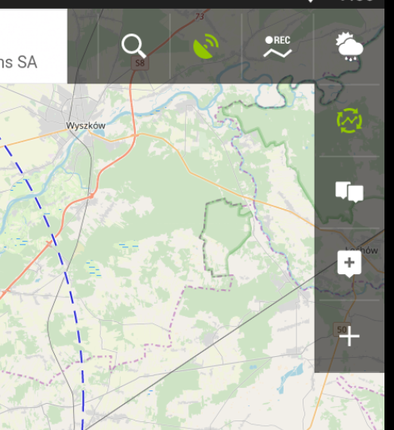
7. Green icon of Live Tracking means that you are using it right now
8. Click Live Tracking icon
9. As WichuR you are in “Test of Wichura” room  
   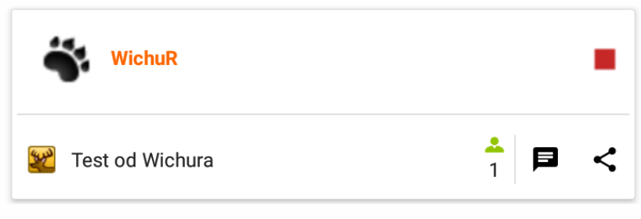
10. There is one other person in it  
    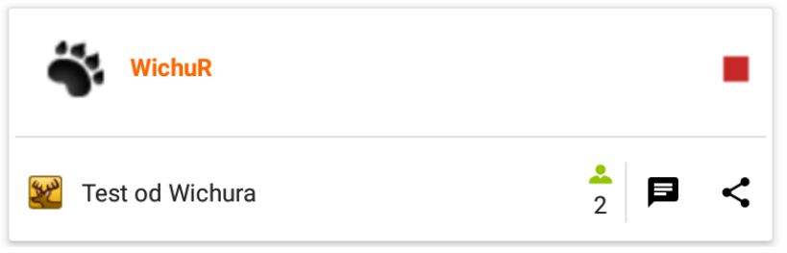
11. Click red square to stop sharing and getting updates  
    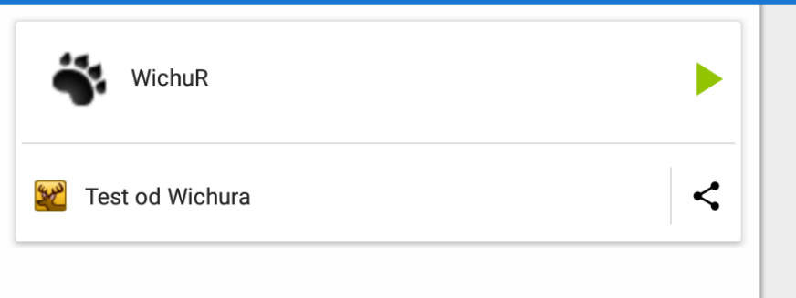
12. Chat icon is green when there are new messages  
    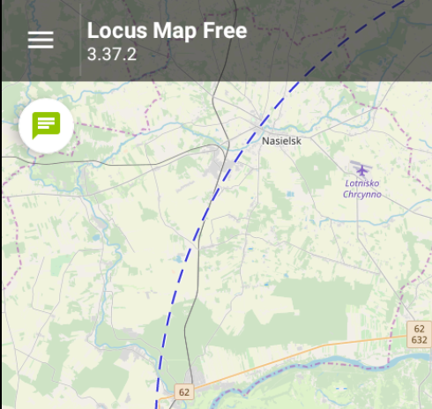
13. Click it to see full history of messages  
    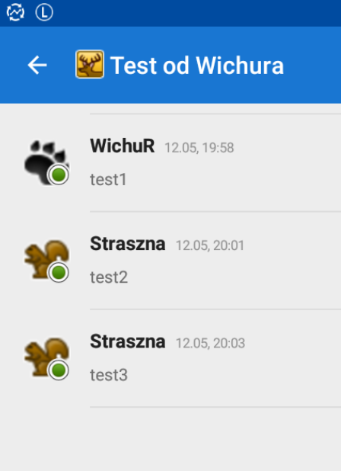
14. Beside typing you can share coordinates. Click “+” sign  
    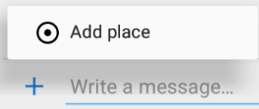
15. Pick way of selecting coordinates  
    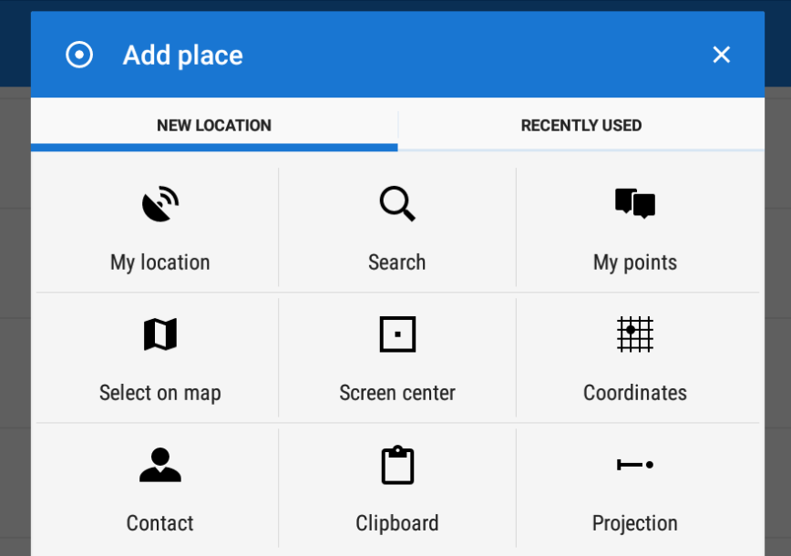
16. Using Select on map function pick a point and confirm  
    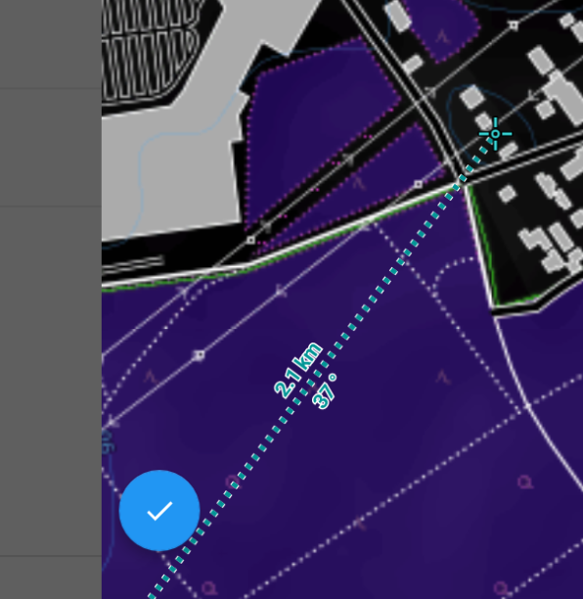
17. Add message and click send  
    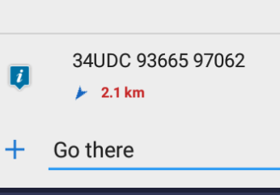
18. Click any send point to select Guide On  
    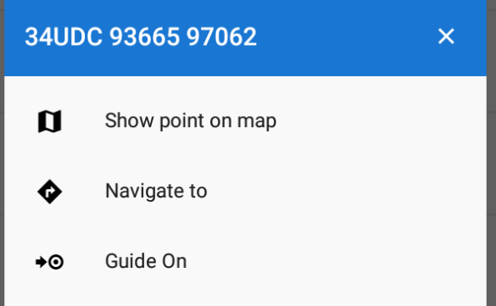
19. Point is added and Guide Is on  
    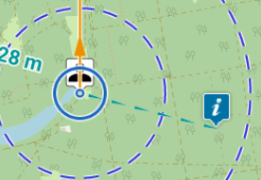
20. Go to Live Tracking from Map Screen
21. Click your nickname
22. Select different frequency to save your battery